As always, these are used for demonstrative purposes and your response will require input from Legal, Compliance and other appropriate business partners.

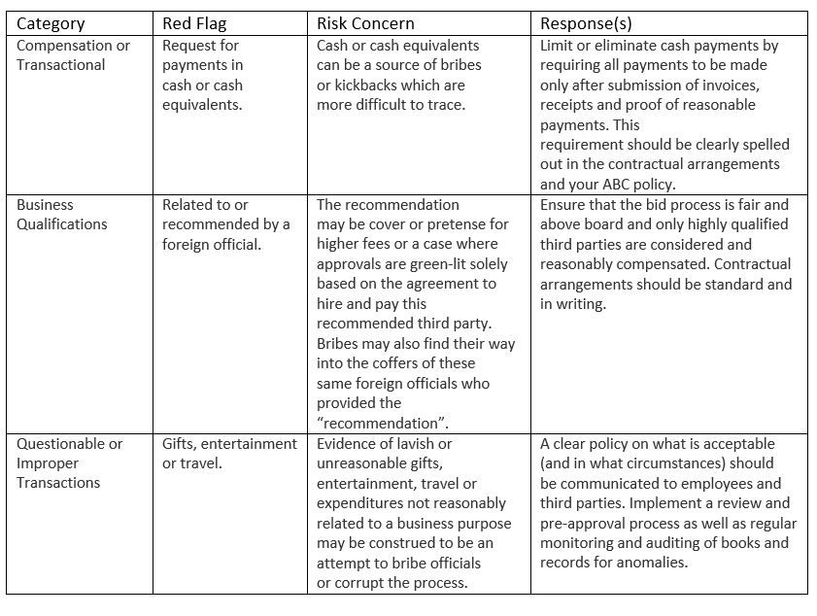

Red Flags
A “red flag” is a fact, event, or set of circumstances, or other information that may indicate a potential legal compliance concern for illegal or unethical business conduct, particularly with regard to corrupt practices and non-compliance with anti-corruption laws.
When conducting due diligence on a third party (or any intermediary), these “red flag” examples should always trigger concern and appropriate review by Legal. While these examples are not exhaustive and may not in themselves constitute or indicate a violation of the FCPA or other applicable Anti-Corruption Laws, they may be indicators of potential current or future anti-corruption non-compliance. Such indicators must be evaluated to understand any actual risks, any reasonable resolution or measures which must be implemented to mitigate a risk, or if Lockheed Martin should not engage the third party because the risk is unacceptable.
7.1 Identifying and Following-Up Red Flags
In all dealings with potential or current consultants or representatives, our customers or other third parties, Company directors, officers and employees must be conscious of any Red Flags that may be present or arise that suggest possible violations of anti-bribery and corruption standards. When a Red Flag is identified you must be sensitive to the risk of corruption it presents. It must be followed up and appropriate steps be taken to prevent the Company being implicated in bribery or corruption, including possible termination of the third-party relationship or walking away from an acquisition, joint venture or business opportunity. In the context of acquisitions, teaming/joint ventures and third-party service providers, the Company has adopted specific due diligence processes specifically designed to detect and address Red Flags. See the Procedure on Anti-Bribery and Corruption Due Diligence.
a. Poor Reputation
- The transaction or the party is in a country known for widespread corruption, as measured by the Transparency International Corruption Perceptions Index or other similar indices
- Party has a poor business reputation or a reputation for unethical conduct, including reports of suspicious, unethical, or unlawful conduct about the party, its sub-agents or its employees
- Party has a history of improper payment practices, such as prior or ongoing formal or informal investigations by law enforcement authorities or prior convictions
- Party has been subject to criminal enforcement actions or civil actions for acts suggesting illegal, improper or unethical conduct
- Allegations the party has made or has a propensity to make prohibited payments or facilitation payments to officials
- Allegations related to integrity, such as a reputation for illegal, improper, or unethical conduct
- Party does not have in place an adequate compliance program or code of conduct or refuses to adopt one
- Other companies have terminated the party for improper conduct
- Information provided about the party or its services or principals is not verifiable by data, only anecdotally
b. Gifts and Business Entertainment:
- extravagant business entertainment, especially involving a Government or Public Official;
- cash and cash equivalents, which include vouchers, and gift cards;
- gifts and entertainment during contract negotiations or government tender processes;
- excessive or lavish entertainment;
- gifts and entertainment to family members and friends;
- entertainment or hospitality where the host is not present; or
- giving and accepting of gifts and entertainment on a frequent basis with the same third party.
c. Potential Conflicts of Interest:
- having a direct or indirect commercial relationship with the Company;
- using Company assets to advance private interests;
- making employment decisions based on a personal, rather than a business basis;
- holding an office or directorship in a company that is in competition with the Company, in which the Company has a commercial interest, or which receives donations or sponsorships from the Company; or
- soliciting employment for a family member or close friend.
d. Third Party Due Diligence Findings:
- indications of a close personal relationship between the third party and a Government or Public Official or customer that could improperly influence a decision;
- recommendation of a third party by a Government or Public Official;
- recommendation of a third party who has a personal, family or business relationship with a Government Official;
- insufficient bona fide business reasons for retaining the third party;
- the third party is not qualified or lacks the necessary experience and resources to perform the functions for which it has been engaged;
- refusal of the third party to contractually commit to compliance with applicable anti- bribery laws and regulations;
- the Company knows or suspects that the third party, any senior personnel that the third party employs or any individuals or entities by whom the third party is owned, controlled or managed, has been involved in illegal or unprofessional conduct or activity or has been accused or convicted of such involvement; or
- indications of previous involvement in behavior contrary to applicable anti-bribery laws and regulations or other legal requirements.
e. Geographic Risks:
The country in which the activity is to take place or where the third party is active or resident does not have a Corruption Perception Index (CPI) score in the top 25% of the countries on the most recent Transparency International CPI (such country being a "high risk country").
f. Accounting and Payments:
payments made or offered in cash, including cash payments or per diems and reimbursements for travel and lodging related expenses, which are paid directly to the Government or Public Officials; inadequately documented payments or expenses; requests for unusual payment channels; excessive fees; deceptive or inaccurate bookkeeping entries, or accounting procedures which would conceal the true nature of the expenses (e.g. entertainment recorded as a training expense); or the use of false documents and invoices.
7.2 Reporting Red Flags
It is the responsibility of the employee who observes or suspects a Red Flag to report the matter to his or her supervisor as well as the Legal Department or the Board of Directors.

Political and charitable donations
Anti-bribery and corruption laws do not prohibit charitable donations, but they do prohibit misusing such donations as a way of covering up bribes and other corrupt advantages. A particular risk arises when donations are made to political individuals or entities because in many cases these donations are used as a vehicle to conceal payments made to corruptly influence government officials.

The organization’s standards
  - SANS does not make contributions or donations to political parties, political organizations, or independent candidates, nor does it incur any political expenditures.
  - Charitable donations are permitted provided they meet the criteria below:
- No donation is accepted or provided if it intends to improperly influence performance or to obtain an improper advantage or may reasonably create such an impression.
- Donations must be fully transparent and recorded fairly and accurately in SANS books and records.
- Always obtain a receipt or other written acknowledgment for any donation made on SANS's behalf.
- No donation should be made in cash or to private accounts.

Acknowledgement
I (print name) ________________________________acknowledge that I have read, understood and agreed to comply with the Anti-Bribery and Corruption Policy. I have not violated the provisions of this Policy and am not aware of any violations of the Policy as of the date hereof.
Signature: ________________________ Date: _________________
Directors and officers of SANS will be required to complete an annual acknowledgement certification.
Original Approval Date:
Approved by:

